GRADE 7 ACCELERATED · UNIT 1 · LESSON 4  Two-Step Equations in Context  Additional Practice 7A.01.04 | Name_________________________  Date__________________________  Period________________________

Lisa solved the equation −2x − 3 = 5. Her work is shown. Use it for question 1.
−2x − 3 + 3 = 5 + 3
−2x = 8
−2x ÷ (−2) = 8 ÷ (−2)
x = 4

1. Use substitution to decide whether Lisa's solution is correct. If it is not, describe her error and solve the equation correctly.

Zoey solved the equation 3m + 5 = 8. Her work is shown. Use it for question 2.
3m + 5 − 5 = 8 − 5
3m = −3
3m ÷ 3 = −3 ÷ 3
m = −1

2. Use substitution to decide whether Zoey's solution is correct. If it is not, describe her error and solve the equation correctly.

For questions 3 through 5, solve the equation, then say what the solution means in the situation.
3. A taxi charges $1.75 plus $0.75 for each mile traveled. Your trip cost $14.50. The equation 1.75 + 0.75x = 14.50 represents the situation.

4. A zipline course charges a flat rate of $75 plus $5.50 for each line you cross. One person's total was $124.50. The equation 75 + 5.50z = 124.50 represents the situation.

5. A runner warms up for 15 minutes and then runs each mile in 6 minutes. The total time is 45 minutes. The equation 15 + 6m = 45 represents the situation.

For questions 6 through 10, solve the equation and check your solution by substitution.
6. 125 = 15 + 5x

 | 7. | 9.2 = 6.1 + | 

8. 17.5c − 15 = 98.75

 | 9. | 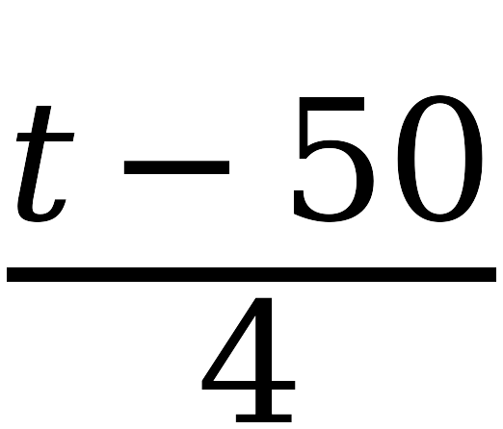 | = 400

10. 16.42 + 2.51r = 26.46

